Home Lab Report: Automated Intrusion Prevention System (IPS)
Engineer: Jordan Schaefer
System Environment: Ubuntu 24.04.4 (Manager), Windows Server 2025 (Agent)

Summary
The objective of this lab was to architect and deploy a functional Security Operations Center (SOC) pipeline using Wazuh. The project successfully integrated a Windows Server endpoint into a centralized monitoring system and implemented an automated "Active Response" mechanism to mitigate SSH brute-force attacks in real-time.

Infrastructure
- SIEM/Manager: Wazuh Manager running on Ubuntu Linux.
- Endpoint: Windows Server running Wazuh Agent.
- Network: Bridged Mode environment for realistic cross-machine communication. NAT Mode would not work for lab purposes.
- Protocol Monitored: Port 22 (OpenSSH for Windows).

Implementation Phases

Phase 0: Installation and Setup
Started with new Virtual Machine to ensure a clean enviornment. Configured each with 3 cores, 6gb ram and 60gb storage as well as the Bridge setting in the network tab.
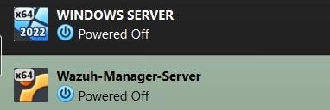
Figure 1: Both ISO's Installed on Virtual Box
Installed Wazuh Dashboard on Ubuntu machine and installed Wazuh Agent on Windows Server machine. Then proceeded with Wazuh setup process on devices.
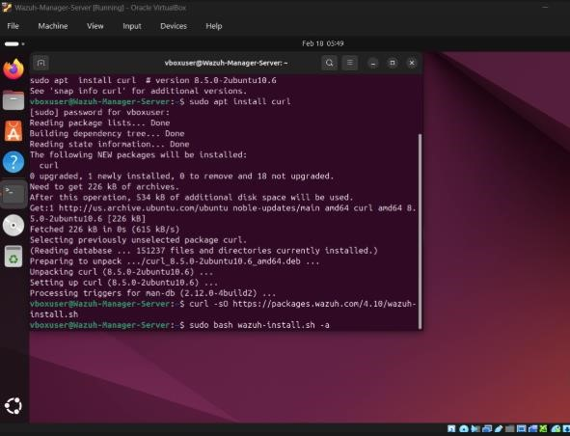
Figure 2: Installing and Downloading Wazuh on Ubuntu
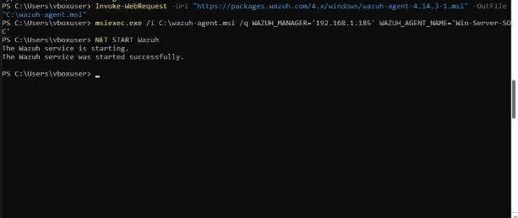
Figure 3: Installing and Downloading Wazuh on Windows Server

Phase I: Log Aggregation & Telemetry
Configured the Windows Server agent to ship Event Channel logs to the manager.
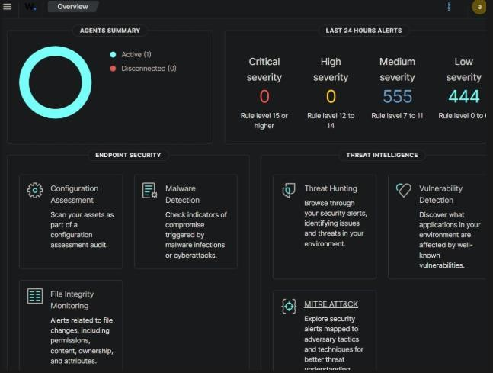
Figure 4: Wazuh Dashboard showing 1 active agent connection (Windows Server Instance)
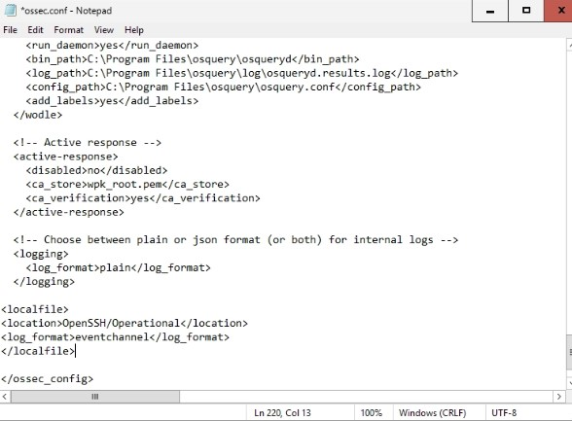
Figure 5: Custom XML Code to tell Wazuh Agent exactly where to read

Phase II: Attack Simulation
First opened port 22 on the windows server machine. Then conducted a brute-force attack from the Ubuntu terminal using repeated failed SSH login attempts.
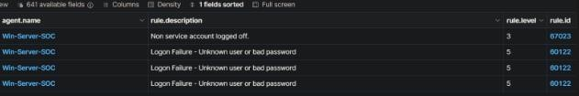
Figure 6: Attack attempts from Ubuntu machine
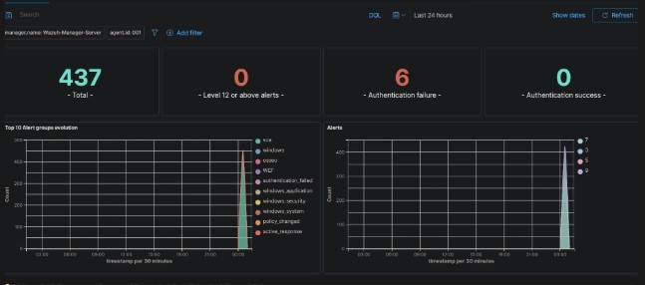
Figure 7: Attack attempts overview. 6 Authentication failures.
Figure 8: The attack used (IP Blurred due to Bridge to Router)

Active Response Configuration
Configured the Wazuh Manager to trigger a netsh firewall block upon detecting Rule ID 60122 (SSH Brute Force) and a few other rule ids. In figure 6 we see the log in attempts are Rule ID 60122, which is exactly what we are trying to block.
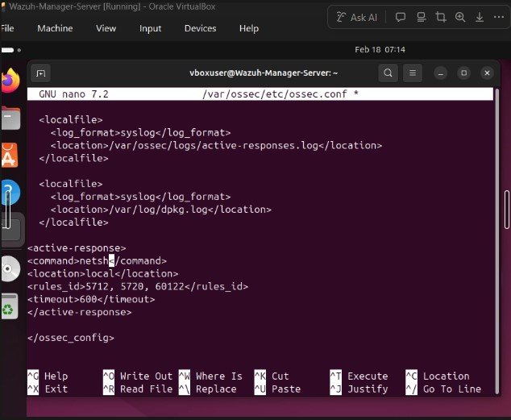
Figure 9:Active Response to block the IP who attempted Rule ID 5712, 5720, 60122 for 600 seconds

Final Validation
After applying the custom response, the attack was repeated. The Wazuh Agent successfully received the command from the manager and injected a dynamic block into the Windows Advanced Firewall.
- Result: Attacker IP was blocked for 600 seconds.
- Evidence: Verified via Wazuh in the Threat Hunter Events tab. (Figure 10)
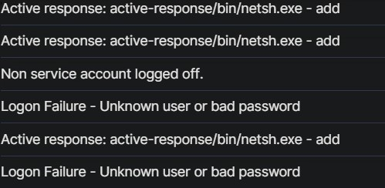
Figure 10: Active Response responding to Rule ID 60122

Conclusion
This lab demonstrates the transition from passive monitoring to active defense and automation. By using knowledge about SIEM software and XML, I successfully implemented an automated mitigation strategy that secures the endpoint against credential stuffing attacks.

